ATAR CHEMISTRY UNITS 3 AND 4

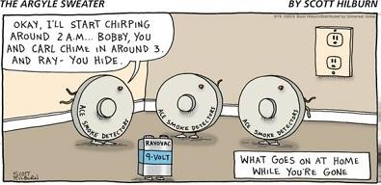

**Extended Response: Electrochemistry**

**Weighting: 5%**

**Validation Test Date: Friday, 15 May (Week 3)**

(Howard 2013)

1. 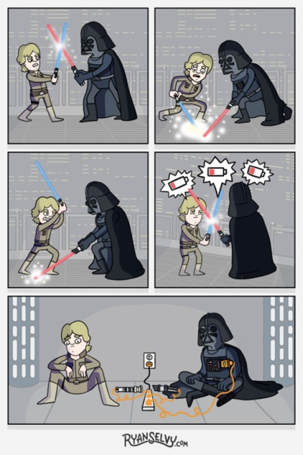Draw up a table that will include the following information about the dry cell (a primary cell), the lead-acid cell (a secondary cell) and the alkaline hydrogen fuel cell. Under the table draw a fully labelled diagram of each of the electrochemical cells previously listed.

* What is the anode composed of?
* What is the cathode composed of?
* What is the electrolyte?
* Write the oxidation half-equation.
* Write the reduction half-equation.
* Write the overall, balanced redox equation.
* What voltage is this cell capable of delivering? Show all working.
* Outline three benefits of using this electrochemical cell.
* Outline three disadvantages of using this electrochemical cell.
* List two environmental impacts of using this electrochemical cell.

(LoganDX 2015)

1. Complete Lucarelli ‘Essential Chemistry ATAR Chemistry Units 3 + 4’ Set 12 (pg 90) questions 2 – 12.
2. You must include correctly referenced sources you have used to get information (you must use at least four sources).

# **Bibliography**

Howard, D. “Handyman Humour 2.” *Howie's Handyman Services.* 29 May 2013. http://www.howieshq.com/howies-blog/handyman-humour-2.html (accessed April 1, 2016).

LoganDX. “If Lightsabers Ran on Current Power Sources.” *Don't Hate the Geek.* 3 September 2015. http://donthatethegeek.com/if-lightsabers-ran-on-current-power-sources/ (accessed April 1, 2016).

mmgteacher. “MMG's English Blog at PMCurie.” *Edublogs.* 2 December 2013. http://englishblogmmg.edublogs.org/tag/humour-2/page/30/ (accessed April 1, 2016).



(mmgteacher 2013)